Junit Sampler

It supports only junit 4.

In this @test method only gets executes

It has test code,failure message and respose code etc..that which matches with response assertions.

Working with Junit Sampler:

Step-1 -Firstly we need to create a package java-

Step-2 And create java class and give test annotation

Step-3 Now create java method.

Step – 4 right click on java project and export

Step 5- select jar file -press next—click on browser—open jmeter lib folder—jmeter has junit folder –give name

**package** jmeter;

**import** org.junit.Assert;

**import** org.junit.Test;

**public** **class** JmeterJunitDemoTest {

@Test

**public** **void** testdemo1()

{

System.***out***.println("Junit is updates soon");

Assert.*assertTrue*(**false**);

}

@Test

**public** **void** testdemo2()

{

System.***out***.println("Junit is updated");

}

}

By clicking on junit 4..we get classname and testmethod default.

Based on the below values we run and check ..it give true or false.

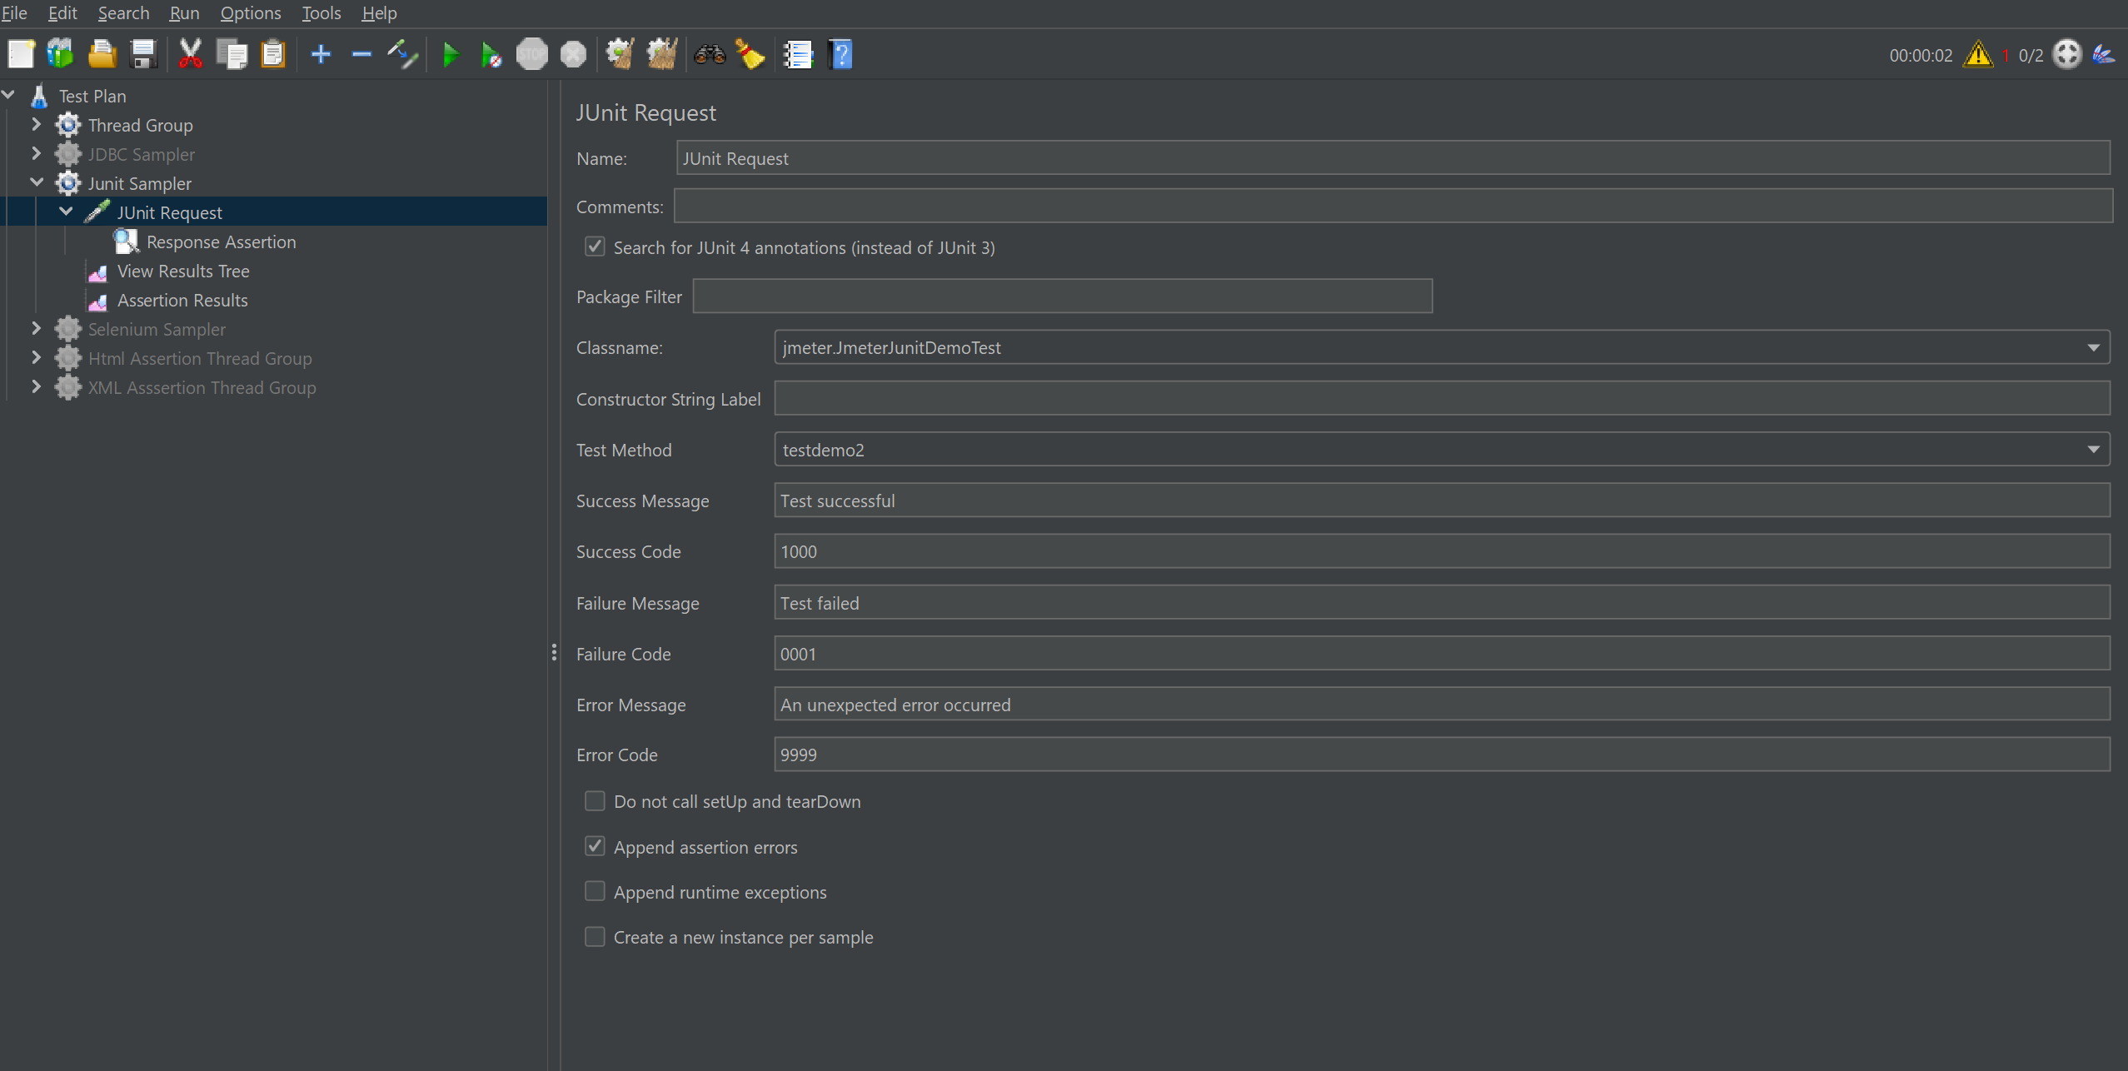

Checking the response code value with Junit Success code..if both matches it runs the scripts and there is no error.

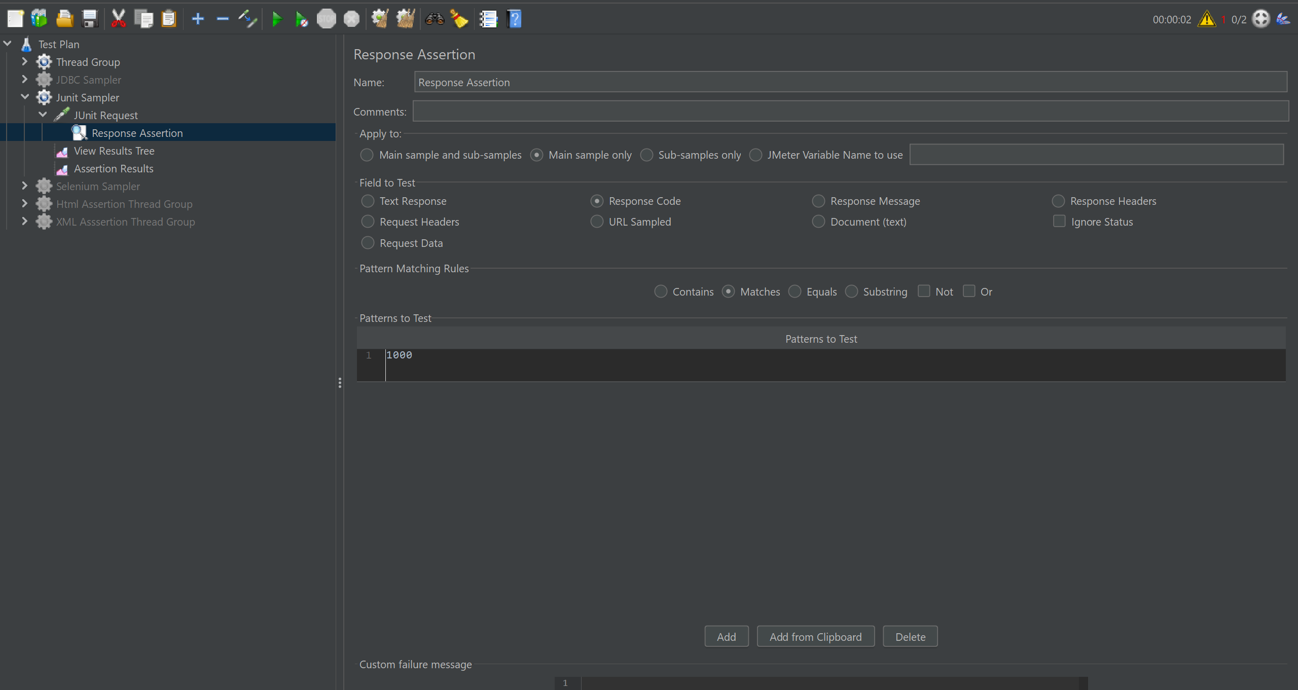

As discussed, both response code and success code matches and script got executed.